**ALBERTA ROYAL PURPLE ASSOCIATION**

**2025 CONFERENCE AND ANNUAL GENERAL MEETING**

**REGISTRATION FORM**

**Hosted by Alberta Royal Purple**

When: June 7th , 2025

Where: Stettler United Church Hall

4820-51 Street, Stettler, AB

Registration fees, early bird prior to May 16, 2025, $ 100.00

Registration May 17 to June 7, 2025, $ 125.00

Extra Banquet Tickets for Saturday evening $ 40.00

TOTAL

$

(Please print clearly)

First name____________________ Last name______________________

Mailing address_______________________________________________

Town_______________________________________________________

Postal code___________________ Phone_________________________

Email_______________________________________________________

Royal Purple Lodge _________________________________ #________

Present Position held in lodge or ARPA____________________________

*Mail registration form and make cheques payable to:*

**Alberta Royal Purple Association**

Mail to: Ida Jorgensen, ARPA Treasurer

Box 1157, Caroline AB T0M0M0

*or*

Etransfer your payment :arpamember@gmail.com

Scan you registration to: arpamember@gmail.com

$________________



**ARPA Conference and AGM Information**

**Early Bird Registrations must be received before May 16th, 2025.**

$100 Registration includes:

Saturday June 7th Conference, AGM Meetings, Education Session.

Meals: Saturday coffee breaks, lunch, and evening banquet with entertainment.

**Extra Meals:**

Saturday Banquet only ticket price - $40.00

**Please advise us with your Registration if you have dietary requests.

**Please book your own rooms, prior to May 9, 2025, as Royal Purple group.**

**Canalta Hotel, 6020 50 Ave, Stettler, AB** [**1-403-742-3371**](tel:+1-403-742-3371)

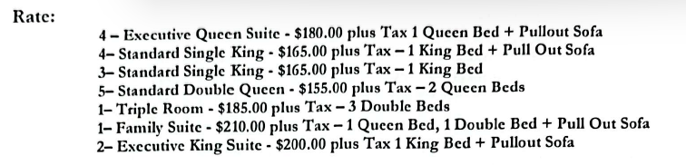

Other Hotels:

Ramada by Wyndham, 6711-49th Ave. 403-742-6555

Camping is available in the town of Stettler.

Additional information regarding amenities in and around Stettler is available on

Town of Stettler website; <https://www.stettler.net>

The Conference Committee would appreciate it if you could bring an item for the Silent Auction or maybe an item for the Food Bank, since the Church runs the Food Bank it would be a kind gesture.

If you have a CRP Lanyard for your Name Badge, bring that along as well.

Hope to see you in June.